**Solar Maximum**

From Wikipedia, the free encyclopedia

*For the spacecraft, see* [*Solar Maximum Mission*](http://en.wikipedia.org/wiki/Solar_Maximum_Mission)*.*

Main article: [Solar cycle](http://en.wikipedia.org/wiki/Solar_cycle)

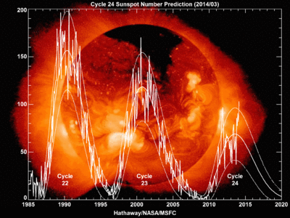

The current prediction for Sunspot Cycle 24 gives a smoothed sunspot number maximum of about 66 in the Summer of 2013. The smoothed sunspot number has already reached 67 (in February 2012) due to the strong peak in late 2011 so the official maximum will be at least this high. The smoothed sunspot number has been flat over the last four months. We are currently over four years into Cycle 24. The current predicted and observed size makes this the smallest sunspot cycle since Cycle 14 which had a maximum of 64.2 in February of 1906. [NASA](http://solarscience.msfc.nasa.gov/predict.shtml)

**Solar maximum** or **solar max** is a normal period of greatest solar activity in the 11 year [solar cycle](http://en.wikipedia.org/wiki/Solar_cycle) of the [Sun](http://en.wikipedia.org/wiki/Sun). During solar maximum, large numbers of [sunspots](http://en.wikipedia.org/wiki/Sunspot) appear and the sun's irradiance output grows by about 0.07%. The increased energy output of solar maxima can impact Earth's global climate and recent studies have shown some correlation with regional weather patterns.

At solar maximum, the Sun's [magnetic field](http://en.wikipedia.org/wiki/Magnetic_field) lines are the most distorted due to the magnetic field on the solar equator rotating at a slightly faster pace than at the solar poles. The [solar cycle](http://en.wikipedia.org/wiki/Solar_cycle) takes an average of about 11 years to go from one solar maximum to the next, with duration observed varying from 9 to 14 years.

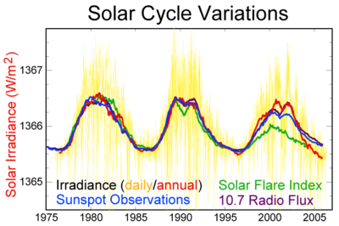

Three recent solar cycles

Large [solar flares](http://en.wikipedia.org/wiki/Solar_flare) often occur during a maximum. For example, the [solar storm of 1859](http://en.wikipedia.org/wiki/Solar_storm_of_1859) struck the Earth with such intensity that the [northern lights](http://en.wikipedia.org/wiki/Aurora_(astronomy)) were visible as far from the poles as [Cuba](http://en.wikipedia.org/wiki/Cuba) and [Hawaii](http://en.wikipedia.org/wiki/Hawaii).

**Predictions**

Predictions of a future maximum's timing and strength are very difficult; predictions vary widely. There was a solar maximum in 2000. In 2006 [NASA](http://en.wikipedia.org/wiki/NASA) initially expected a solar maximum in 2010 or 2011, and thought that it could be the strongest since [1958](http://en.wikipedia.org/wiki/Solar_cycle_19). However, the solar maximum was not declared to have occurred until 2014, and even then was ranked among the weakest on record.

**Film**

[IMAX](http://en.wikipedia.org/wiki/IMAX) [documentary](http://en.wikipedia.org/wiki/Documentary_film) about solar maximum called *Solarmax*.

[NASA CME documentary](http://www.nasa.gov/mission_pages/sunearth/news/taste-solarmax.html) X class Corona Mass Ejection 2012-07-14 documentary

**Grand solar minima and maxima**

Main article: [Solar variation](http://en.wikipedia.org/wiki/Solar_variation)

Grand solar maxima occur when several solar cycles exhibit greater than average activity for decades or centuries. Solar cycles still occur during these grand solar maximum periods but the intensity of those cycles are greater. Grand solar maxima have shown some correlation with global and regional climate changes.

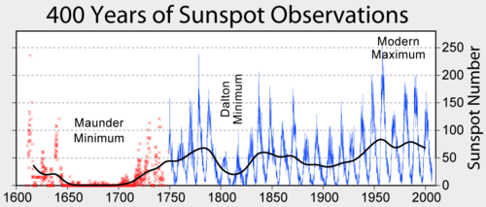

400 year history of [sunspot numbers](http://en.wikipedia.org/wiki/Wolf_number).

|  |  |  |
| --- | --- | --- |
| **Solar minimum events and approximate dates** | | |
| **Event** | **Start** | **End** |
| Homeric minimum | 950BC | 800BC |
| Oort minimum (see [Medieval Warm Period](http://en.wikipedia.org/wiki/Medieval_Warm_Period)) | 1040 | 1080 |
| Medieval maximum (see [Medieval Warm Period](http://en.wikipedia.org/wiki/Medieval_Warm_Period)) | 1100 | 1250 |
| Wolf minimum | 1280 | 1350 |
| [Spörer Minimum](http://en.wikipedia.org/wiki/Sp%C3%B6rer_Minimum) | 1450 | 1550 |
| [Maunder Minimum](http://en.wikipedia.org/wiki/Maunder_Minimum) | 1645 | 1715 |
| [Dalton Minimum](http://en.wikipedia.org/wiki/Dalton_Minimum) | 1790 | 1820 |
| [Modern Maximum](http://en.wikipedia.org/wiki/Modern_Maximum) | 1900 | present |

A list of historical Grand minima of solar activity includes also Grand minima ca. 690 AD, 360 BC, 770 BC, 1390 BC, 2860 BC, 3340 BC, 3500 BC, 3630 BC, 3940 BC, 4230 BC, 4330 BC, 5260 BC, 5460 BC, 5620 BC, 5710 BC, 5990 BC, 6220 BC, 6400 BC, 7040 BC, 7310 BC, 7520 BC, 8220 BC, 9170 BC.

**See also**

* [Solar wind](http://en.wikipedia.org/wiki/Solar_wind)
* [Solar variation](http://en.wikipedia.org/wiki/Solar_variation)
* [Solar minimum](http://en.wikipedia.org/wiki/Solar_minimum)
* [List of solar cycles](http://en.wikipedia.org/wiki/List_of_solar_cycles) – table of solar cycles
* [Solar Maximum Mission](http://en.wikipedia.org/wiki/Solar_Maximum_Mission)